CPE301 – SPRING 2019

MIDTERM 1

Student Name: Rimon Sawa

Student #:5001529281

Student Email: sawar1@unlv.nevada.edu

Primary Github address: <https://github.com/sawar1/UNLV301>

Directory: Midterm1

1. **COMPONENTS LIST AND CONNECTION BLOCK DIAGRAM w/ PINS**

The components used in this project were the Atmega xplained mini, a FTDI chip, the esp8266 wifi chip, and the lm34 temperature sensor

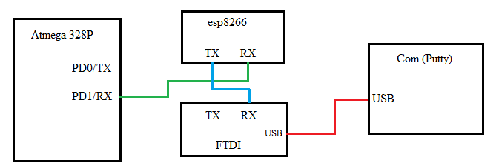

I have the Atmega xplained mini writing to the esp8266(For some reason It would only work when I connected the RX port of the mini to the RX port of the esp8266) and the esp8266 writing to the FTDI chip which would display what the esp8266 was writing back on putty.

1. **INITIAL/MODIFIED/DEVELOPED CODE OF TASK 1/A**

#include <avr/io.h>

#include <avr/interrupt.h>

#define *F_CPU* 16000000L

#include <util/delay.h>

#include <stdlib.h>

#define BAUD 9600

volatile int ovrflw; // global variable for keeping track of # of times Timer0 overflows

volatile *uint8_t* ADCvalue; // Global variable, set to volatile if used with ISR

// functions

void initUART();

void writeChar(unsigned char c);

void writestring(char *c);

void writefloat(float c);

int main(void){

initUART(); // Initialize UART

// initialize ADC

DDRC = 0; // Set PORTC as input for adc

DIDR0 = 0x1; // Disable digital input on ADC0 pin

ADMUX = 0; // ADC0 (PC.0) used as analog input

ADMUX |= (1 << REFS0); // use AVcc as the reference

ADMUX |= (1 << ADLAR); // Right adjust for 8 bit resolution

ADCSRA = 0x87; // Enable ADC, system clock, 10000111

ADCSRB = 0x0; // Free running mode

// initialize timer0 with starting value of 0, normal mode with no prescaler

TCNT0 = 0;

TCCR0A = 0;

TCCR0B |= 2;

// enable interrupts

TIMSK0 |= (1 << TOIE0); // enable overflow interrupt

sei(); // enable global interrupts

while (1);

return 0;

}

void initUART() {

unsigned int baudrate;

// Set baud rate: UBRR = [F_CPU/(16*BAUD)] -1

baudrate = ((*F_CPU*/16)/BAUD) - 1;

UBRR0H = (unsigned char) (baudrate >> 8);

UBRR0L = (unsigned char) baudrate;

UCSR0B |= (1 << RXEN0) | (1 << TXEN0); // Enable receiver and transmitter

UCSR0C |= (1 << UCSZ01) | (1 << UCSZ00); // Set data frame: 8 data bits, 1 stop bit, no parity

}

void writeChar(unsigned char c) {

UDR0 = c; // Display character on serial (i.e., PuTTY) terminal

*_delay_ms*(10); // delay for 200 ms

}

void writestring(char *c){

unsigned int i = 0;

while(c[i] != 0)

writeChar(c[i++]);

}

// this interrupt service routine (ISR) runs whenever an overflow on Timer0 occurs

ISR (TIMER0_OVF_vect) {

// Variable Declarations

char output[6]; // Output string based on ADC

float temperature; // Voltage received by ADC then edited for Temperature

char *AT = "AT \r\n";

char *CIPMUX = "AT+CIPMUX=0 \r\n";

char *ATCW = "AT+CWJAP=\"Virus Detected\",\"Sawas5+3\" \r\n";

char *CIPSTART = "AT+CIPSTART=\"TCP\",\"api.thingspeak.com\",80 \r\n";

char *CIPSEND = "AT+CIPSEND=44";

char *SEND_DATA = "GET /update?key=M52FZABUR6UTS03B&field2=";

char *ENTER = "\r\n";

if (ovrflw == 7500) {

ADCSRA |= (1 << ADSC); // Start conversion

while((ADCSRA&(1<<ADIF))==0); // Wait for conversion to finish

ADCvalue = ADCH; // Only need to read the high value for 8 bit then equation for Fahrenheit

temperature = (ADCvalue * 5.0 / 256) * 100; // Temperature

*dtostrf*(temperature, 0, 0, output); // Float to char* conversion

ovrflw = 0; // reinitialize ovrflw

*_delay_ms*(200);

initUART(); // initialize usart

*_delay_ms*(500);

writestring(AT);

*_delay_ms*(2000);

writestring(CIPMUX);

*_delay_ms*(5000);

writestring(ATCW);

*_delay_ms*(5000);

writestring(CIPSTART);

*_delay_ms*(5000);

writestring(CIPSEND);

writeChar('\r');

writeChar('\n');

*_delay_ms*(5000);

writestring(SEND_DATA);

*_delay_ms*(1000);

writestring(output);

*_delay_ms*(500);

writestring(ENTER);

*_delay_ms*(1000);

for(int i=0; i < 1000; i++)

{

*_delay_ms*(1000);

}

}

else

ovrflw++; // increment ovrflw

}

1. **SCHEMATICS**

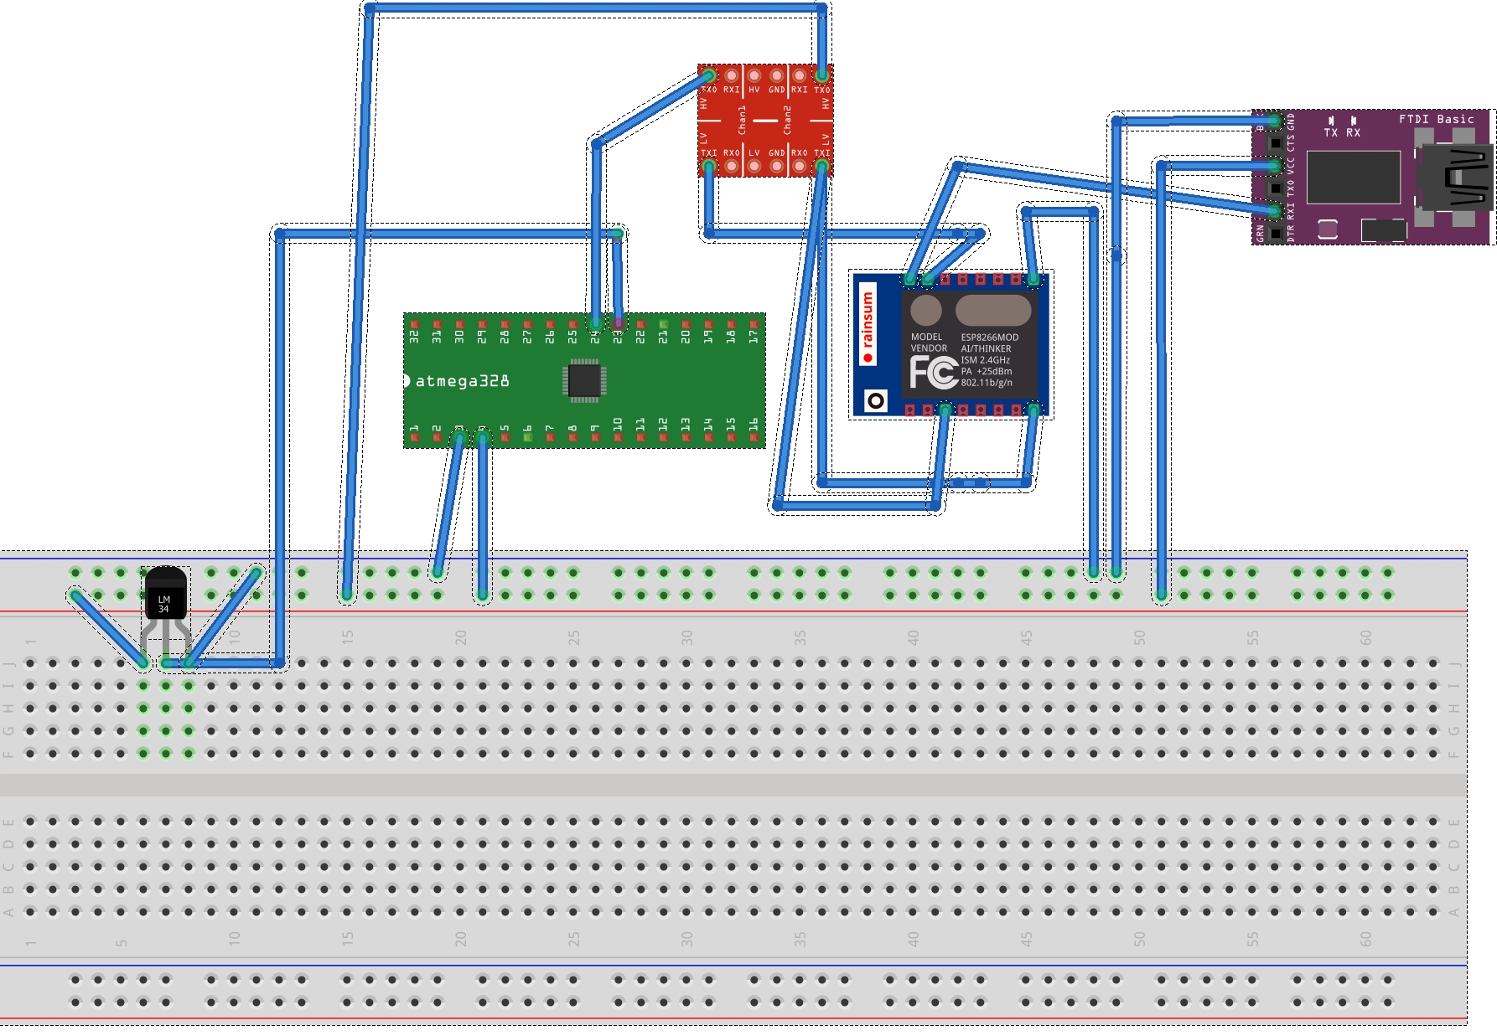

Figure 1: Fritzing Schematic

1. **SCREENSHOTS OF EACH TASK OUTPUT (ATMEL STUDIO OUTPUT)**

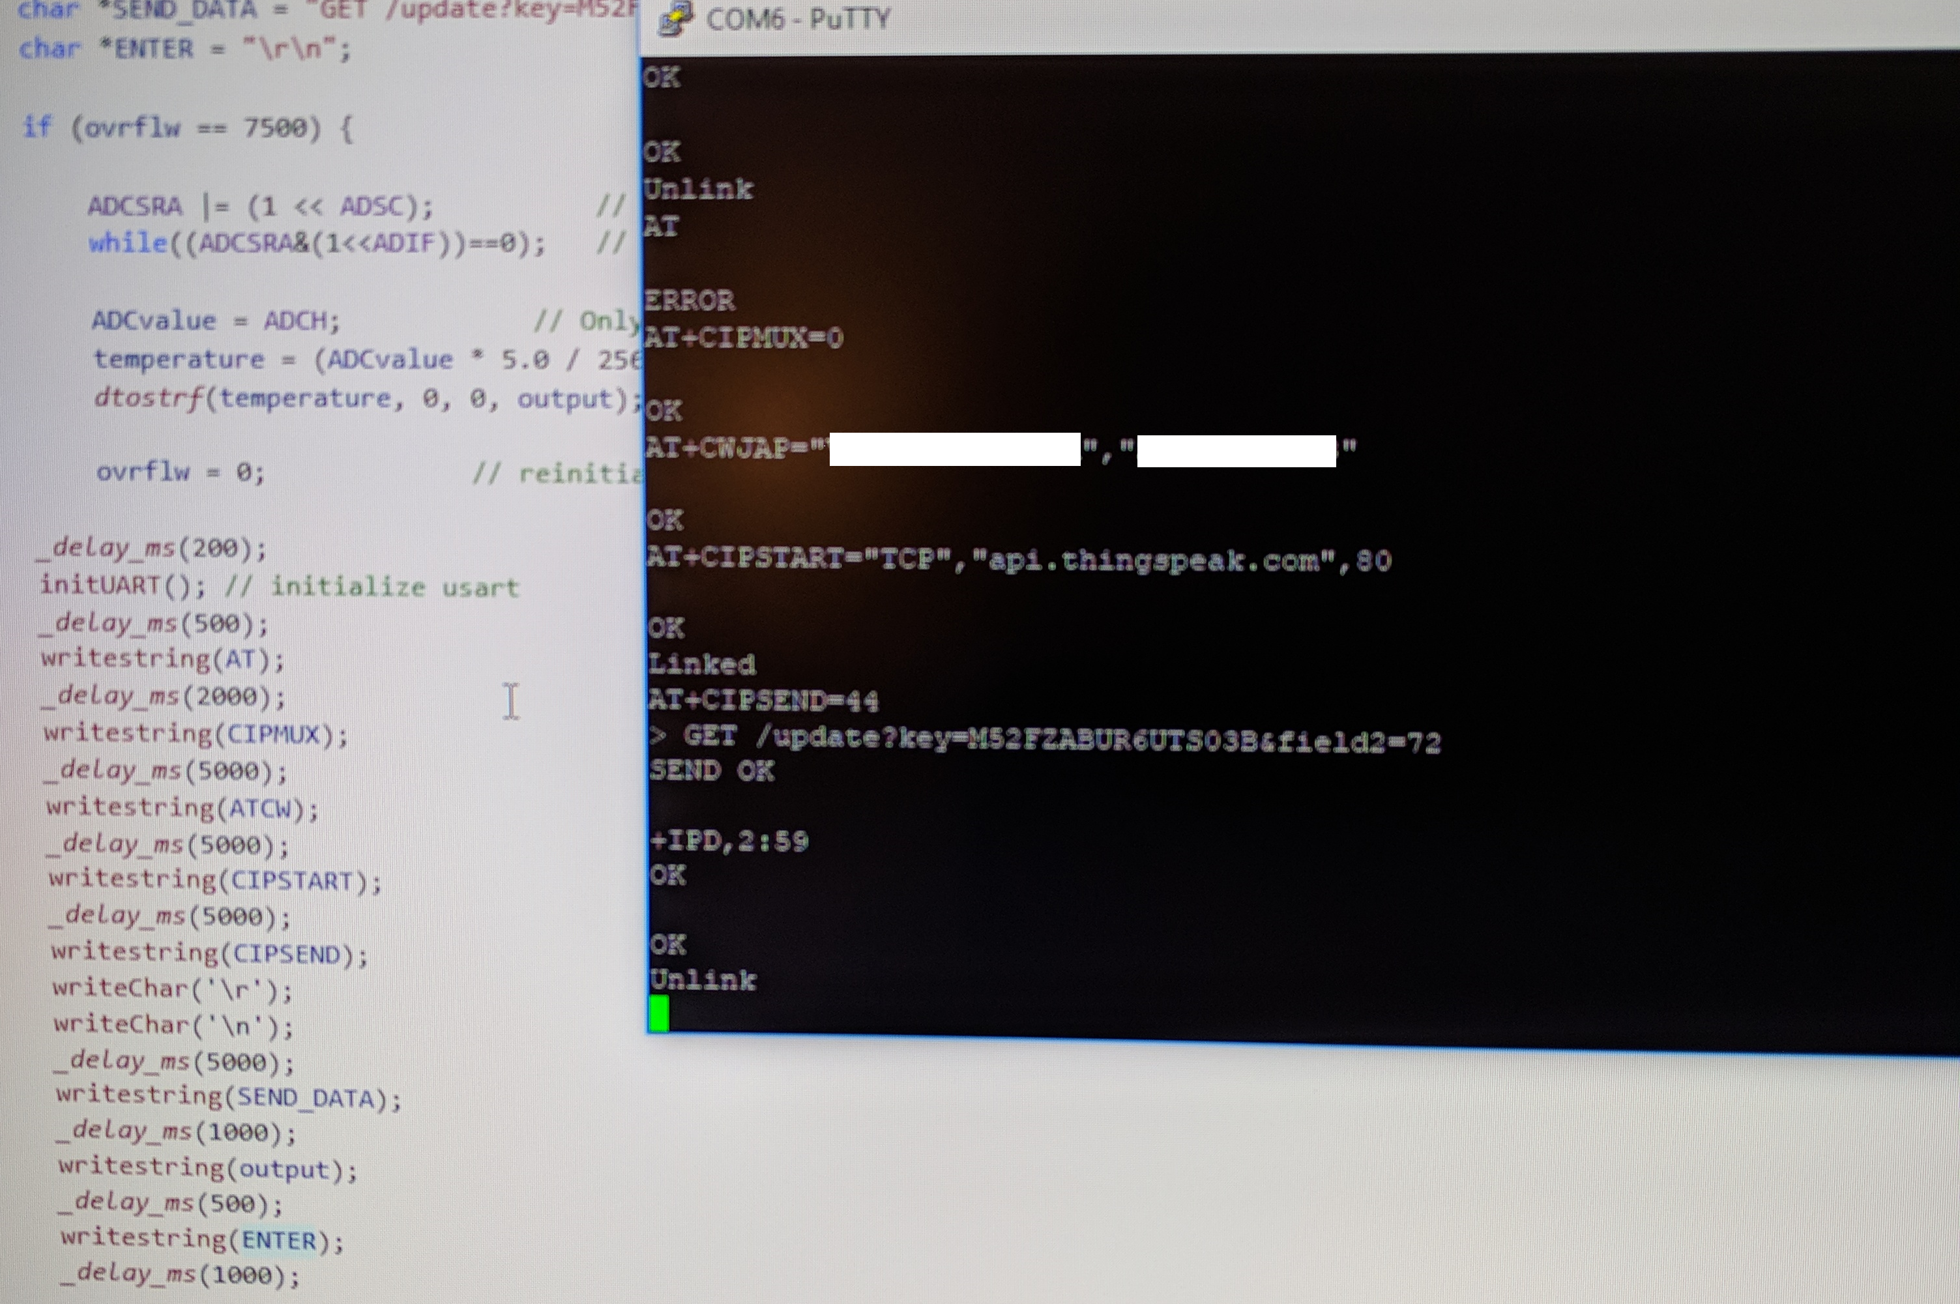

Figure 2: Screenshot of putty terminal

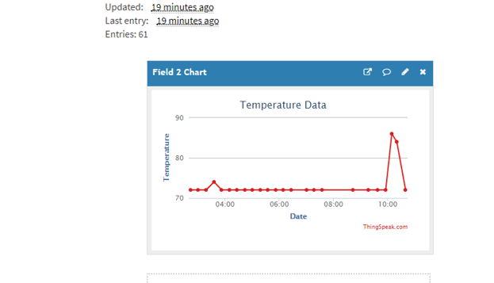

Figure 3: Temperature data graph on Thinkspeak

The temperature was very consistent so for the last couple of temperature reading I held onto the sensor to get some variance in the temperature as you can see with the spike at the end.

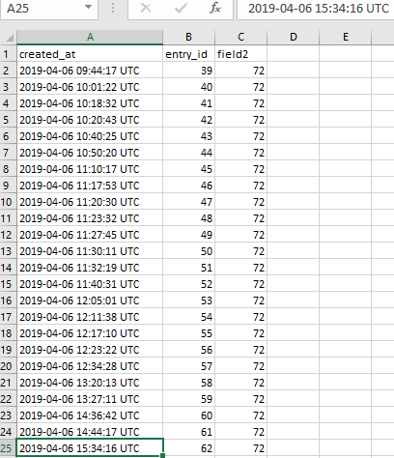

Figure 4: Data exported from thinkspeak channel

1. **SCREENSHOT OF EACH DEMO (BOARD SETUP)**

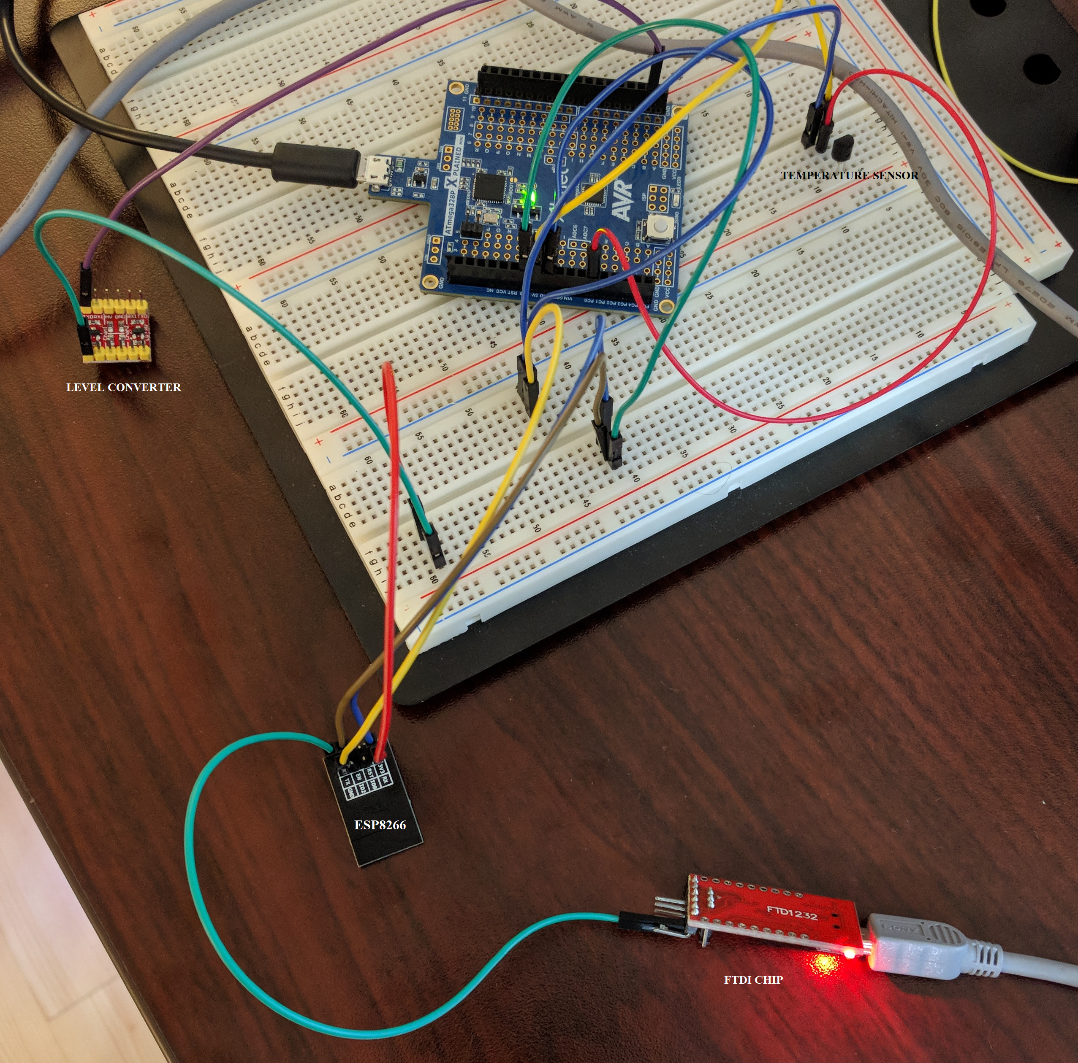

1. **VIDEO LINKS OF EACH DEMO**

None

1. **GITHUB LINK OF THIS DA**

<https://github.com/sawar1/UNLV301>

**Student Academic Misconduct Policy**

<http://studentconduct.unlv.edu/misconduct/policy.html>

“This assignment submission is my own, original work”.

RIMON SAWA